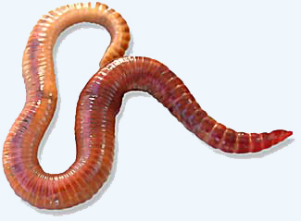
You will need:
- Worm Booklet
- Composting Worms
- Paper Plates
- Spoons
- Magnifying glass
- Ruler
- Worm Investigation Sheet
- Pencils
- “Diary of a Worm” by Doreen Cronin

Directions
- Read through the Worm Booklet.

- Put one or two worms and a small amount of compost on a plate to observe.

- Use magnifiers and rulers to investigate and fill out the “Worm Investigation Sheet”.

- Be very careful and respectful of the worms.

- If you have enough time, read “Diary of a Worm” to finish.

Red Wigglers (Eisenia fedida eye-SEN-ee-uh FE-ti-duh) are one of over 4,400 earthworm species. It is a species of earthworm adapted to decaying organic material. These worms thrive in rotting vegetation, compost, and manure. They are rarely found in soil, instead preferring conditions that are unfavorable to some other worms. They are commonly used as composting worms because they are extremely efficient. Nightcrawlers, Lumbricus terrestris, are the large subsoil dwellers commonly used for fish bait. The earthworm is one of nature’s top “soil scientists” The earthworm is responsible for a lot of the things that help make our soil good enough to grow healthy plants and provide us food! They break down organic matter like leaves and grass into things that plants can use. When they eat, they leave behind “castings” that are a very valuable type of fertilizer. Slime, a secretion of earthworms, contains nitrogen. Nitrogen is an important nutrient for plants. The sticky slime helps to hold clusters of soil particles together.

